FAA PRACTICAL TEST
ELIGIBILITY & ENDORSEMENT
REQUIREMENTS PART 61/141
PRIVATE ASEL INITIAL
PRIVATE AMEL INITIAL
PRIVATE AMEL ADD ON
INSTRUMENT RATING AIRPLANE
COMMERCIAL ASEL INITIAL
COMMERCIAL ASEL ADD ON
COMMERCIAL AMEL INITIAL
COMMERCIAL AMEL ADD ON
CFI ASEL INITIAL
CFI ASEL ADD ON
CFI AMEL INITIAL
MEI ADD ON
CFII ADD ON
CFI REINSTATEMENT
CFI RENEWAL - FIRE
BASIC GROUND INSTRUCTOR
ADVANCED GROUND INSTRUCTOR
INSTRUMENT GROUND INSTRUCTOR
GOLD SEAL FLIGHT INSTRUCTOR
ATP AMEL INITIAL
ATP ASEL ADD ON
RESTRICTED ATP LIMITATION REMOVAL
RETESTING AFTER FAILURE
SPORT PILOT
RECREATIONAL PILOT

COMMERCIAL ASEL – COMMERCIAL ROTORCRAFT TRANSITION
FOREIGN PILOT NOTES
SIMULATOR NOTES

PRIVATE ASEL INITIAL
FAR 61 ELIGIBILITY CONFIRMATION WORKSHEET

COMPLETED
 | IACRA or 8710-1 | Completed and Submitted
 | English Proficient | Speak, read, write & understand
 | Minimum age | 17
 | Photo ID | Government issued, current, verify name and address matches 8710-1
 | Citizenship | If dual citizenship, call the FSDO, Country of citizenship is especially important on IACRA.
 | Pilot Certificate | Signed, valid
 | Medical | 3rd class, note limitations, Basic Med
 | Knowledge Test | Original Test Results with passing score, within last 24 months

DATE COMPLETED | XC AIRPORT  IDENTIFIERS | 61 AERONAUTICAL  EXPERIENCE REQUIREMENTS
 |  | 40 hrs Total
 |  | 20 hrs Dual
 |  | 10 hrs Solo
 |  | 10 hrs PIC
 |  | 3 hrs XC Dual
 |  | 5 hrs XC Solo
3 hrs Dual Instrument - Simulated or IMC
3.0 hrs Should not be combined with Night Training
 |  | 3 hrs Night Dual
 |  | 10 Dual Night TO/LDs Full Stop
 |  | 1 Dual Night XC 100+nm
3 hrs Dual within last 2 calendar months
may be from other than Rec CFI
1 Solo XC of 150nm or greater with full stop landings at each airport with one
50+ nm segment
 |  | 3 Solo TO/LDs at Towered Airport Daytime VFR
 |  | 61.105(a) must receive and log ground training
DATE  COMPLETED | Verify Endorsements Exist and Valid
 | Pre-Solo Aeronautical Knowledge Test
 | Initial Solo
 | 90 Day Solo | Must be current
 | Initial XC
 | Each XC Trip
 | TSA Verification of U.S. Citizenship | TSA (Instructor’s Responsibility)
 | TSA Approval by Alien Flight Student Program | TSA (Instructor’s Responsibility)

Endorsements Required: Must match AC61-65J. See https://www.wificfi.com/endorsements

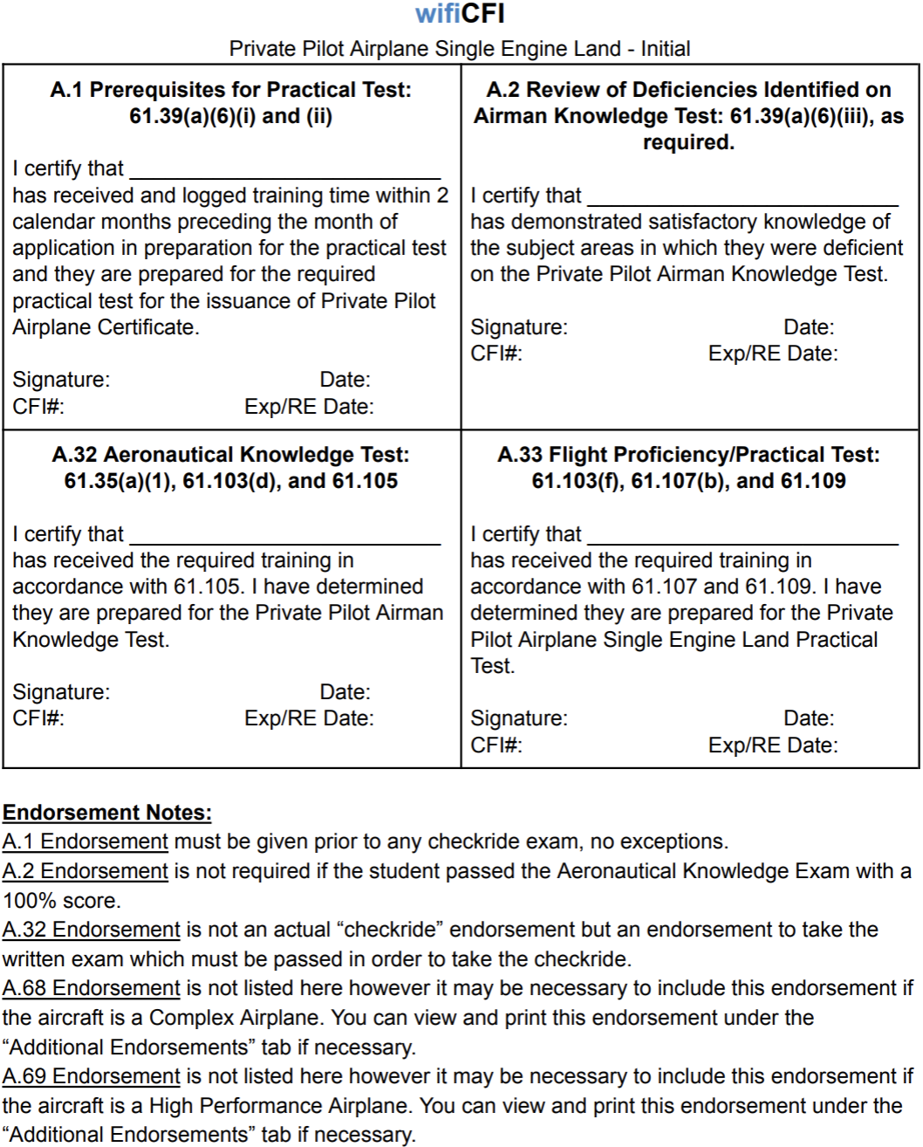

PRIVATE ASEL INITIAL
FAR 141 ELIGIBILITY CONFIRMATION WORKSHEET

COMPLETED
 | IACRA or 8710-1 | Completed and Submitted
 | English Proficient | Speak, read, write & understand
 | Minimum age | 17
 | Photo ID | Government issued, current, verify name and address matches 8710-1
 | Citizenship | If dual citizenship, call the FSDO, Country of citizenship is especially important on IACRA.
 | Pilot Certificate | Signed, valid
 | Medical | 3rd class, note limitations, Basic Med
 | Knowledge Test | Passing score, within last 24 months
 | 141 Graduation Certificate | Valid within 60 days – Cannot be extended with a Discontinuance.  One certificate from the UNO ground school and another Carver Aero/Oracle

DATE COMPLETED | XC AIRPORT  IDENTIFIERS | 141 AERONAUTICAL  EXPERIENCE REQUIREMENTS
 |  | 35 hrs Total
 |  | 20 hrs Dual
 |  | 5 hrs Solo
 |  | 5 hrs PIC
 |  | 3 hrs XC Dual
3 hrs Dual Instrument - Simulated or IMC
3.0 hrs Should not be combined with Night Training
 |  | 3 hrs Night Dual
 |  | 10 Dual Night TO/LDs Full Stop
 |  | 1 Dual Night XC 100+nm
3 hrs Dual within last 60 days
still the old verbiage, not updated in 141 regulations
 |  | 1 Solo XC of 100nm with 3 airports with full stop landings & one 50+ nm segment
 |  | 3 Solo TO/LDs at Towered Airport Daytime VFR
35 hrs received & logged of ground training
Graduation certificate may satisfy this requirement
DATE  COMPLETED | Verify Endorsements Exist and Valid
 | Pre-Solo Aeronautical Knowledge Test
 | Initial Solo
 | 90 Day Solo | Must be current
 | Initial XC
 | Each XC Trip
 | TSA Verification of U.S. Citizenship | TSA (Instructor’s Responsibility)
 | TSA Approval by Alien Flight Student Program | TSA (Instructor’s Responsibility)

Endorsements Required: Must match AC61-65J. See https://www.wificfi.com/endorsements

d
PRIVATE AMEL INITIAL
IACRA or 8710-1 | Completed and Submitted
English Proficient | Speak, read, write & understand
Minimum age | 17
Photo ID | Government issued, current, verify name and address matches 8710-1
Citizenship | If dual citizenship, call the FSDO, Country of citizenship is especially important on IACRA.
Pilot Certificate | Signed, valid
Medical | 3rd class, note limitations, Basic Med
Knowledge Test | Passing score, within last 24 months
141 Graduation Certificate | Valid within 60 days – Cannot be extended with a Discontinuance.  One certificate from the UNO ground school and another Carver Aero/Oracle
61 AERONAUTICAL  EXPERIENCE REQUIREMENTS |  | 141 AERONAUTICAL  EXPERIENCE REQUIREMENTS
40 hrs Total |  | 35 hrs Total
20 hrs Dual |  | 20 hrs Dual
3 hrs Dual XC |  | 3 hrs Dual XC
3 hrs Dual Instrument - Simulated or IMC  Should not be combined with first 3.0 of Night Training. |  | 3 hrs Dual Instrument - Simulated or IMC  Should not be combined with Night Training
3 hrs Dual Night |  | 3 hrs Dual Night
1 Dual Night XC 100+nm |  | 1 Dual Night XC 100+nm
10 Dual Night TO/LDs Full Stop |  | 10 Dual Night TO/LDs Full Stop
3 hrs Dual within last 2 calendar months  may be from other than Rec CFI |  | 3 hrs Dual within last 60 days  still the old verbiage, not updated in 141 regulations
10 hrs Solo |  | 5 hrs Solo
One Solo XC of 150nm or greater with full stop landings at each airport. One 50+ nm segment |  | One Solo XC of 100nm with 3 airports with full stop landings & one 50+ nm segment
5 hrs Solo XC
3 Solo TO/LDs at Towered Airport Daytime VFR |  | 3 Solo TO/LDs at Towered Airport Daytime VFR
61.105(a) must receive and log ground training |  | 35 hrs received & logged of ground training  Graduation certificate satisfies this requirement
Verify Endorsements Exist and Valid
Pre-Solo Aeronautical Knowledge Test
Initial Solo
90 Day Solo | Must be current
Initial XC
Each XC Trip
TSA Verification of U.S. Citizenship | TSA (Instructor’s Responsibility)
TSA Approval by Alien Flight Student Program | TSA (Instructor’s Responsibility)

Endorsements Required: Must match AC61-65J. See https://www.wificfi.com/endorsements

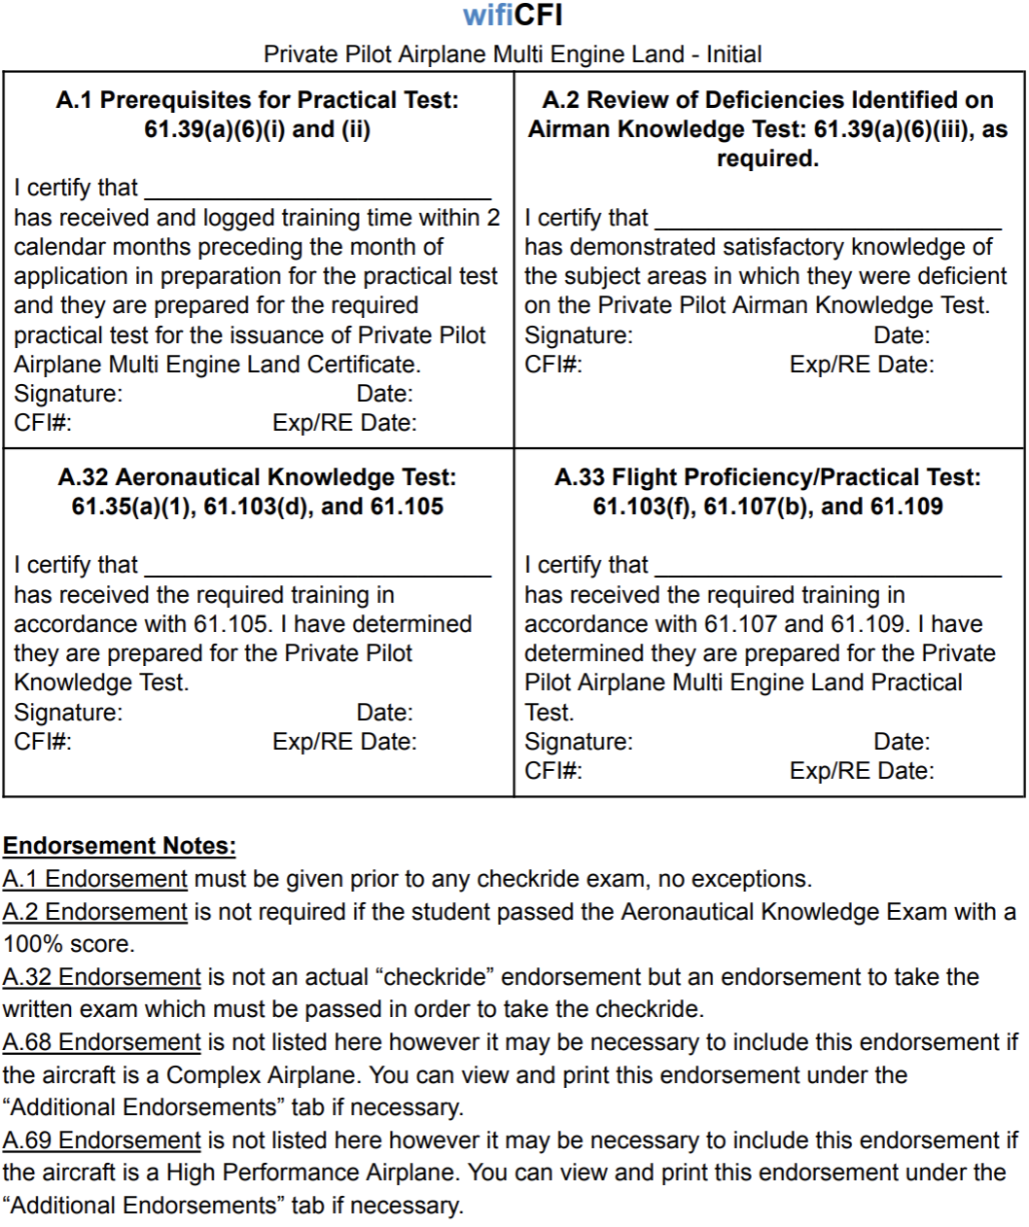

INSTRUMENT AIRPLANE RATING
FAR 61 ELIGIBILITY CONFIRMATION WORKSHEET

COMPLETED
 | IACRA or 8710-1 | Completed and Submitted
 | English Proficient | Speak, read, write & understand
 | Minimum age | 18
 | Photo ID | Government issued, current, verify name and address matches 8710-1
 | Citizenship | If dual citizenship, call the FSDO, Country of citizenship is especially important on IACRA.
 | Pilot Certificate | Signed, valid
 | Medical | 3rd class, note limitations, Basic Med
 | Knowledge Test | Passing score, within last 24 months
 | 141 Graduation Certificate | Valid within 60 days – Cannot be extended with a Discontinuance.  One certificate from the UNO ground school and another Carver Aero/Oracle

DATE COMPLETED | XC AIRPORT  IDENTIFIERS | 61 AERONAUTICAL  EXPERIENCE REQUIREMENTS
 |  | 50 hrs of XC PIC, 10 hrs in Airplane
 |  | 40 hrs Simulated or Actual Instrument
Training Devices:
10 hrs may be used in an BATD
20 hrs of instrument received in an AATD
(School must possess FSDO LOA granting approval of ATD)
 |  | 15 hours Simulated or Actual Instrument Dual from CFII
One Dual XC flight in an airplane with a CFII, under IFR, filed ATC facility, and involves—
(A) 250nm along airways or by directed routing from an ATC Facility. Note: Direct distance of 250nm between airports is not required
(B) An instrument approach at each airport; and
(C) 3 different kinds of approaches only, not nav aids
Note: 3 different airports not required.
 |  | Received and logged ground training from a CFII or accomplished a home-study course
3 hrs of instrument flight training from a CFII
Note: Instruction may be from any CFII.

Endorsements Required: Must match AC61-65J. See https://www.wificfi.com/endorsements

INSTRUMENT AIRPLANE RATING
FAR 141 ELIGIBILITY CONFIRMATION WORKSHEET

COMPLETED
 | IACRA or 8710-1 | Completed and Submitted
 | English Proficient | Speak, read, write & understand
 | Minimum age | 18
 | Photo ID | Government issued, current, verify name and address matches 8710-1
 | Citizenship | If dual citizenship, call the FSDO, Country of citizenship is especially important on IACRA.
 | Pilot Certificate | Signed, valid
 | Medical | 3rd class, note limitations, Basic Med
 | Knowledge Test | Passing score, within last 24 months
 | 141 Graduation Certificate | Valid within 60 days – Cannot be extended with a Discontinuance.  One certificate from the UNO ground school and another Carver Aero/Oracle

DATE COMPLETED | XC AIRPORT  IDENTIFIERS | 141 AERONAUTICAL  EXPERIENCE REQUIREMENTS
 |  | No XC PIC Required
 |  | 35 hrs Simulated or Actual Instrument
See Flight Simulators Section or 141 App. C

School must possess FSDO LOA granting approval of Training Device
One Dual XC flight in an airplane with a CFII, under IFR, filed ATC facility, that involves—
(A) 250nm along airways or by directed routing from an ATC Facility, 100nm straight line distance.
(B) An instrument approach at each airport; and
(C) 3 different kinds of approaches only, not nav aids
Note: 3 different airports not required.
 |  | 30 hrs ground training received and logged from a CFII
3 hrs of instrument flight training from a CFII
Note: Instruction may be from any CFII.

Endorsements Required: Must match AC61-65J. See https://www.wificfi.com/endorsements
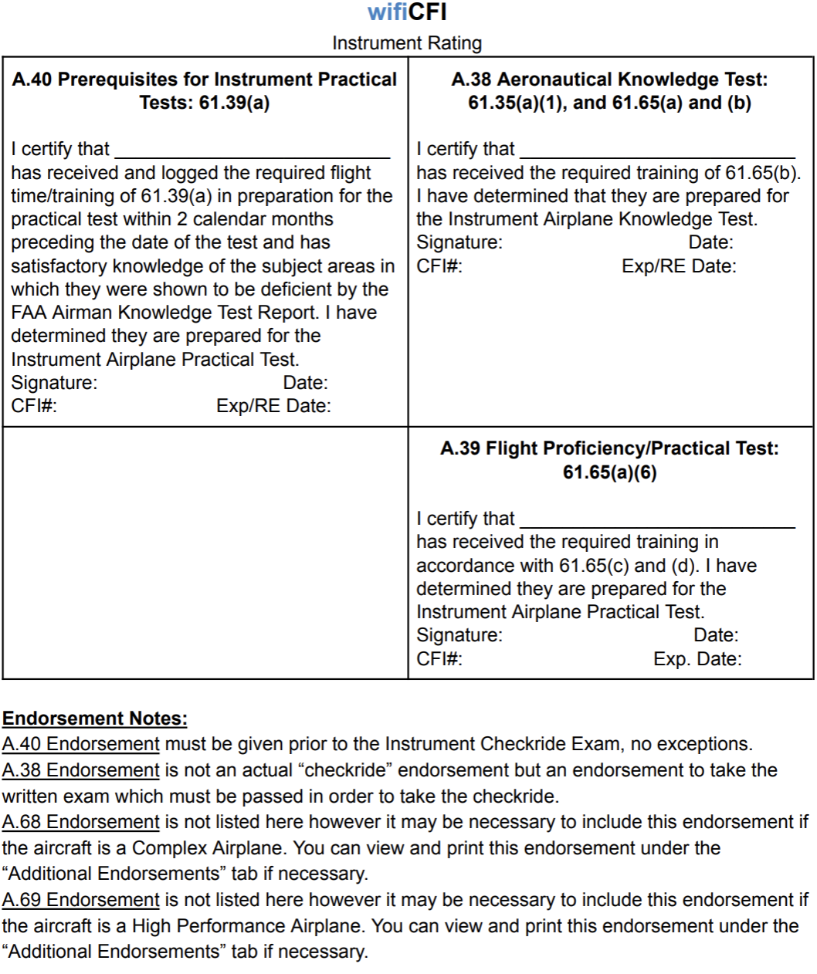
PRIVATE AMEL ADD-ON
IACRA or 8710-1 | Completed and Submitted
English Proficient | Speak, read, write & understand
Minimum age | 17
Photo ID | Government issued, current, verify name and address matches 8710-1
Citizenship | If dual citizenship, call the FSDO, Country of citizenship is especially important on IACRA.
Pilot Certificate | Signed, valid
Medical | 3rd class, note limitations, Basic Med
141 Graduation  Certificate | Valid within 60 days – Cannot be extended with a Discontinuance.  One certificate from the UNO ground school and another Carver Aero/Oracle
61 COMMERCIAL AMEL ADD-ON  AERONAUTICAL EXPERIENCE REQUIREMENTS |  | 141 COMMERCIAL AMEL ADD-ON  AERONAUTICAL EXPERIENCE REQUIREMENTS
Received and logged ground training from an MEI, (with or without a CFII) or completed a home-study course |  | Received and logged ground training from an MEI,  (with or without a CFII)
Received and logged flight training from an MEI, (with or without a CFII) and no minimum time requirements |  | Received and logged flight training from an MEI, (with or without a CFII) and no minimum time requirements
Note: ACS - AOA X. Multiengine Operations Task C. and Task D must be tested if the Applicant holds Instrument Airplane privileges.  An Applicant is prohibited from receiving the limitation, “Airplane Multiengine VFR Only”, if they hold an Instrument Airplane Rating before this Practical Test.  Reference: Appendix 7 – Private ACS. |  | Note: ACS - AOA X. Multiengine Operations Task C. and Task D must be tested if the Applicant holds Instrument Airplane privileges.  An Applicant is prohibited from receiving the limitation, “Airplane Multiengine VFR Only”, if they hold an Instrument Airplane Rating before this Practical Test.  Reference: Appendix 7 – Private ACS.

Endorsements Required: Must match AC61-65J. See https://www.wificfi.com/endorsements

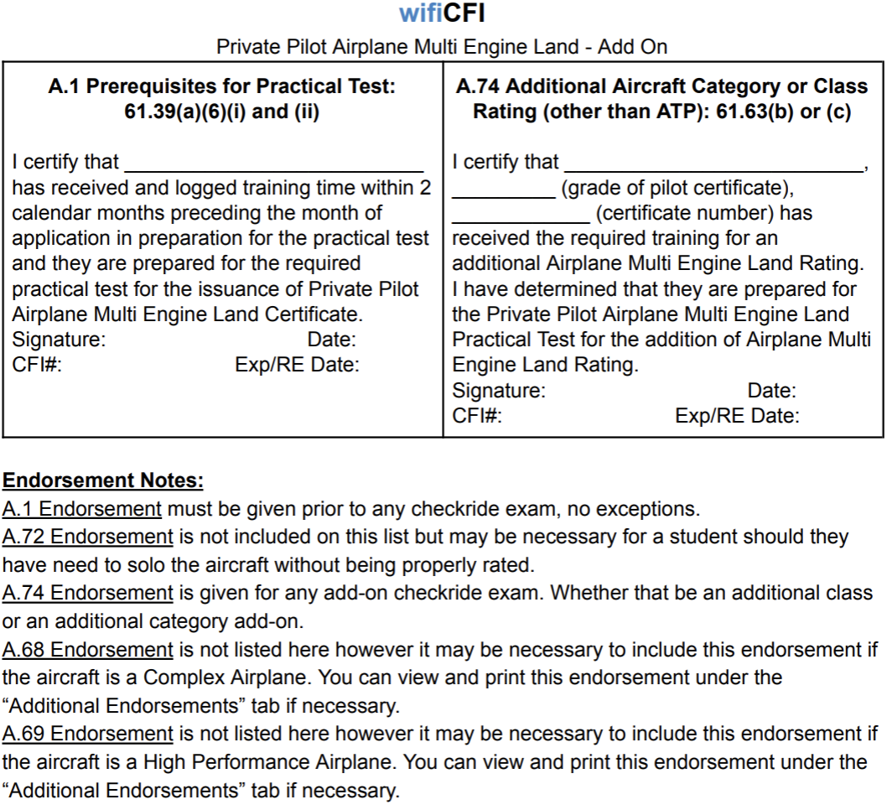
COMMERCIAL PILOT ASEL INITIAL
IACRA or 8710-1 | Completed and Submitted
English Proficient | Speak, read, write & understand
Minimum age | 18
Photo ID | Government issued, current, verify name and address matches 8710-1
Citizenship | If dual citizenship, call the FSDO, Country of citizenship is especially important on IACRA.
Pilot Certificate | Valid, signed, must hold Instrument Rating or Concurrently Enrolled for 141
Medical | 3rd class, note limitations, Basic Med
Knowledge Test | Passing score, within last 24 months
141 Graduation Certificate | Valid within 60 days – Cannot be extended with a Discontinuance.  One certificate from the UNO ground school and another Carver Aero/Oracle
61 COMMERCIAL ASEL  AERONAUTICAL EXPERIENCE REQUIREMENTS |  | 141 COMMERCIAL ASEL  AERONAUTICAL EXPERIENCE REQUIREMENTS
250 Hours Total Flight Time
 |  | 120 hrs Total Training Time in specific 141 Commercial Program
See Flight Simulators Section or 61  School must possess FSDO LOA granting approval of Training Device |  | See Flight Simulators Section or 141 App. D  School must possess FSDO LOA granting approval of Training Device
100 hrs Powered Aircraft/50 Airplane |  | 100 hrs Powered Aircraft/50 Airplane
100 hrs PIC/50 Airplane |  | 100 hrs PIC/50 Airplane
50 hrs PIC XC/10 Airplanes |  | 50 hrs PIC XC/10 Airplanes
20 hrs ASEL Training listed in § 61.127(b)(1) of  this part that includes at least the following: |  | 55 hrs ASEL training listed in § 141 App D. of this part that includes at least the following:
10 hrs Instrument Training (5 hrs must be in ASEL)  *If planning to combine the use of 10 hours from the Instrument Rating training, then the following regulation “training also used for Commercial 61.129(a)(3)(i)” must be in the remarks section of the logbook for each of the 10 hours logged during the Instrument Rating training.  5 hrs of approved simulator time may be used if logged correctly.  Private pilot Instrument time cannot be used.  §61.129(a)(3)(i) states: “Ten hours of instrument training using a view-limiting device including attitude instrument flying, partial panel skills, recovery from unusual flight attitudes, and intercepting and tracking navigational systems.” Note: Statement may be used as an endorsement. |  | 10 hrs instrument training (5 hours must be in ASEL)  *If planning to combine the use of 10 hours from 141 Instrument Rating training, then it must be approved in specific 141 Syllabus.
10 hrs training in Complex ASEL, turbine-powered, or TAA Note: Time applied must be after private pilot. |  | 10 hrs training in Complex ASEL, turbine-powered, or TAA Time applied must be after private pilot.
One Dual Day XC ASEL, 2-hr, a total straight-line distance +100nm from the original point of departure |  | One Dual Day XC ASEL, 2-hr, a total straight-line distance +100nm from the original point of departure
If Applicant attempts to use the Instrument xc in combination to satisfy the 2-hour xc, then they must appropriately log that the training time meets standards of both 61.65(instrument) and 61.127(Commercial). If logged appropriately, then the instrument xc training time can also count as a commercial 2-hour Dual xc.  Ref: FAA Legal Interpretation Letter  Student Pilot cross countries may not be combined for Commercial. |  | *If planning to combine xc requirements from 141 Instrument Rating training, then it must be approved in specific 141 Syllabus.  Student Pilot cross countries may not be combined for Commercial.
One Dual Night XC ASEL 2-hr, straight-line distance of +100nm from original point of departure |  | One Dual Night XC ASEL 2-hr, straight-line distance of +100nm from the original point of departure
One Solo, Day or Night, XC ASEL, 300nm, landing at three points, one segment of a straight-line distance at least 250nm from original point of departure  Note: 250nm flight segment length is not required. – Ref: FAA Legal Interpretation Letter - 12/29/2020 Anthony Walker – attached below. |  | One Solo XC ASEL with landings at a minimum of three points, one segment of a straight-line distance at least 250nm from original point of departure  Note: 250nm flight segment length is not required. – Ref: FAA Legal Interpretation Letter - 12/29/2020 Anthony Walker - attached below.
10 hrs Solo ASEL or PDPIC, on areas of operation in 61.127(b)(1) and acquired after Private training. |  | 10 hrs Solo ASEL or PDPIC, on areas of operation in (d)(1) of section 4 of App. D and acquired after Private training.
5 hrs Solo ASEL or PDPIC, Night, VFR, 10 full stop TO/LDs in traffic pattern with open ATC tower |  | 5 hrs Solo ASEL or PDPIC, Night, VFR, 10 full stop TO/LDs in traffic pattern with open ATC tower
Received and logged ground training from a CFI or accomplished a home-study course |  | 35 hrs Ground Training – Graduation Certificate possibly satisfies requirement
3 hrs ASEL training within 2 calendar months |  | 3 hrs ASEL training within 2 calendar months
Endorsements Required: Must match AC61-65J. See https://www.wificfi.com/endorsements

COMMERCIAL PILOT ASEL INITIAL
FAR 61 ELIGIBILITY CONFIRMATION WORKSHEET

COMPLETED
 | IACRA or 8710-1 | Completed and Submitted
 | English Proficient | Speak, read, write & understand
 | Minimum age | 18
 | Photo ID | Government issued, current, verify name and address matches 8710-1
 | Citizenship | If dual citizenship, call the FSDO, Country of citizenship is especially important on IACRA.
 | Pilot Certificate | Valid, signed, must hold Instrument Rating or Concurrently Enrolled for 141
 | Medical | 3rd class, note limitations, Basic Med
 | Knowledge Test | Passing score, within last 24 months
 | 141 Graduation Certificate | Valid within 60 days – Cannot be extended with a Discontinuance.  One certificate from the UNO ground school and another Carver Aero/Oracle

DATE COMPLETED | XC AIRPORT  IDENTIFIERS | 61 AERONAUTICAL  EXPERIENCE REQUIREMENTS
 |  | 250 Hours Total Flight Time
See Flight Simulators Section or 61
School must possess FSDO LOA granting approval of Training Device
 |  | 100 hrs Powered Aircraft/50 Airplane
 |  | 100 hrs PIC/50 Airplane
 |  | 50 hrs PIC XC/10 Airplanes
20 hrs ASEL Training listed in § 61.127(b)(1) of
this part that includes at least the following:
10 hrs Instrument Training (5 hrs must be in ASEL)
*If planning to combine the use of 10 hours from the Instrument Rating training, then the following regulation “training also used for Commercial 61.129(a)(3)(i)” must be in the remarks section of the logbook for each of the 10 hours logged during the Instrument Rating training.
5 hrs of approved simulator time may be used if logged correctly.
Private pilot Instrument time cannot be used.
§61.129(a)(3)(i) states: “Ten hours of instrument training using a view-limiting device including attitude instrument flying, partial panel skills, recovery from unusual flight attitudes, and intercepting and tracking navigational systems.” Note: Statement may be used as an endorsement.
 |  | 10 hrs training in Complex ASEL, turbine-powered, or TAA Note: Time applied must be after private pilot.
 |  | One Dual Day XC ASEL, 2-hr, a total straight-line distance +100nm from the original point of departure
If Applicant attempts to use the Instrument xc in combination to satisfy the 2-hour xc, then they must appropriately log that the training time meets standards of both 61.65(instrument) and 61.127(Commercial). If logged appropriately, then the instrument xc training time can also count as a commercial 2-hour Dual xc.
Ref: FAA Legal Interpretation Letter
Student Pilot cross countries may not be combined for Commercial.
 |  | One Dual Night XC ASEL 2-hr, straight-line distance of +100nm from original point of departure
One Solo, Day or Night, XC ASEL, 300nm, landing at three points, one segment of a straight-line distance at least 250nm from original point of departure
Note: 250nm flight segment length is not required. – Ref: FAA Legal Interpretation Letter - 12/29/2020 Anthony Walker – attached below.
 |  | 10 hrs Solo ASEL or PDPIC, on areas of operation in 61.127(b)(1) and acquired after Private training.
 |  | 5 hrs Solo ASEL or PDPIC, Night, VFR, 10 full stop TO/LDs in traffic pattern with open ATC tower
 |  | Received and logged ground training from a CFI or accomplished a home-study course
 |  | 3 hrs ASEL training within 2 calendar months

Endorsements Required: Must match AC61-65J. See https://www.wificfi.com/endorsements

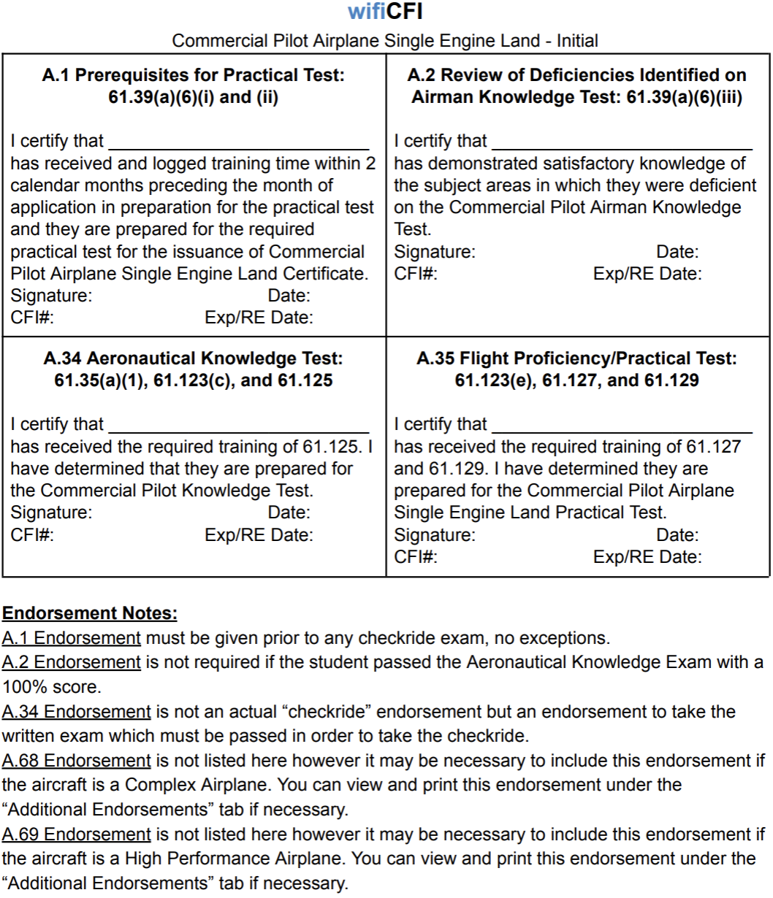

COMMERCIAL PILOT ASEL INITIAL
FAR 141 ELIGIBILITY CONFIRMATION WORKSHEET

COMPLETED
 | IACRA or 8710-1 | Completed and Submitted
 | English Proficient | Speak, read, write & understand
 | Minimum age | 18
 | Photo ID | Government issued, current, verify name and address matches 8710-1
 | Citizenship | If dual citizenship, call the FSDO, Country of citizenship is especially important on IACRA.
 | Pilot Certificate | Valid, signed, must hold Instrument Rating or Concurrently Enrolled for 141
 | Medical | 3rd class, note limitations, Basic Med
 | Knowledge Test | Passing score, within last 24 months
 | 141 Graduation Certificate | Valid within 60 days – Cannot be extended with a Discontinuance.  One certificate from the UNO ground school and another Carver Aero/Oracle

DATE COMPLETED | XC AIRPORT  IDENTIFIERS | 141 AERONAUTICAL  EXPERIENCE REQUIREMENTS
 |  | 120 hrs Total Training Time in specific 141 Commercial Program
See Flight Simulators Section or 141 App. D
School must possess FSDO LOA granting approval of Training Device
 |  | 100 hrs Powered Aircraft/50 Airplane
 |  | 100 hrs PIC/50 Airplane
 |  | 50 hrs PIC XC/10 Airplanes
 |  | 55 hrs ASEL training listed in § 141 App D. of this part that includes at least the following:
10 hrs instrument training (5 hours must be in ASEL)
*If planning to combine the use of 10 hours from 141 Instrument Rating training, then it must be approved in specific 141 Syllabus.

 |  | 10 hrs training in Complex ASEL, turbine-powered, or TAA Time applied must be after private pilot.
 |  | One Dual Day XC ASEL, 2-hr, a total straight-line distance +100nm from the original point of departure
*If planning to combine xc requirements from 141 Instrument Rating training, then it must be approved in specific 141 Syllabus.

Student Pilot cross countries may not be combined for Commercial.
 |  | One Dual Night XC ASEL 2-hr, straight-line distance of +100nm from the original point of departure
One Solo XC ASEL with landings at a minimum of three points, one segment of a straight-line distance at least 250nm from original point of departure
Note: 250nm flight segment length is not required. – Ref: FAA Legal Interpretation Letter - 12/29/2020 Anthony Walker - attached below.
 |  | 10 hrs Solo ASEL or PDPIC, on areas of operation in (d)(1) of section 4 of App. D and acquired after Private training.
 |  | 5 hrs Solo ASEL or PDPIC, Night, VFR, 10 full stop TO/LDs in traffic pattern with open ATC tower
 |  | 35 hrs Ground Training – Graduation Certificate possibly satisfies requirement
 |  | 3 hrs ASEL training within 2 calendar months

Endorsements Required: Must match AC61-65J. See https://www.wificfi.com/endorsements

COMMERCIAL PILOT AMEL INITIAL
IACRA or 8710-1 | Completed and Submitted
English Proficient | Speak, read, write & understand
Minimum age | 18
Photo ID | Government issued, current, verify name and address matches 8710-1
Citizenship | If dual citizenship, call the FSDO, Country of citizenship is especially important on IACRA.
Pilot Certificate | Valid, signed, must hold Instrument Rating or Concurrently Enrolled for 141
Medical | 3rd class, note limitations, Basic Med
Knowledge Test | Passing score, within last 24 months
141 Graduation Certificate | Valid within 60 days – Cannot be extended with a Discontinuance.  One certificate from the UNO ground school and another Carver Aero/Oracle
61 COMMERCIAL AMEL  AERONAUTICAL EXPERIENCE REQUIREMENTS |  | 141 COMMERCIAL AMEL  AERONAUTICAL EXPERIENCE REQUIREMENTS
250 Hours Total Flight Time
 |  | 120 hrs Total Training Time in specific 141 Commercial Program
See Flight Simulators Section or 61  School must possess FSDO LOA granting approval of Training Device |  | See Flight Simulators Section or 141 App. D  School must possess FSDO LOA granting approval of Training Device
100 hrs Powered Aircraft/50 Airplane |  | 100 hrs Powered Aircraft/50 Airplane
100 hrs PIC/50 Airplane |  | 100 hrs PIC/50 Airplane
50 hrs PIC XC/10 Airplanes |  | 50 hrs PIC XC/10 Airplanes
20 hrs AMEL Training listed in § 61.127(b)(1) of  this part that includes at least the following: |  | 55 hrs AMEL training listed in § 141 App D. of this part that includes at least the following:
10 hrs Instrument Training (5 hrs must be in AMEL)  *If planning to combine the use of 10 hours from the Instrument Rating training, then the following regulation “training also used for Commercial 61.129(a)(3)(i)” must be in the remarks section of the logbook for each of the 10 hours logged during the Instrument Rating training.  5 hrs of approved simulator time may be used if logged correctly.  Private pilot Instrument time cannot be used.  §61.129(a)(3)(i) states: Ten hours of instrument training using a view-limiting device including attitude instrument flying, partial panel skills, recovery from unusual flight attitudes, and intercepting and tracking navigational systems. |  | 10 hrs instrument training (5 hours must be in ASEL)  *If planning to combine the use of 10 hours from 141 Instrument Rating training, then it must be approved in specific 141 Syllabus.
10 hrs training in Complex AMEL, a turbine-powered, or TAA Time applied must be after private pilot. |  | 10 hrs training in Complex AMEL, a turbine-powered, or TAA Time applied must be after private pilot.
One Dual Day XC AMEL, 2-hr, a total straight-line distance +100nm from the original point of departure |  | One Dual Day XC AMEL, 2-hr, a total straight-line distance +100nm from the original point of departure
If Applicant attempts to use the Instrument xc in combination to satisfy the 2-hour xc, then they must appropriately log that the training time meets standards of both 61.65(instrument) and 61.127(Commercial). If logged appropriately, then the instrument xc training time can also count as a commercial 2-hour Dual xc.  Ref: FAA Legal Interpretation Letter  Student Pilot cross countries may not be combined for Commercial. |  | *If planning to combine xc requirements from 141 Instrument Rating training, then it must be approved in specific 141 Syllabus.  Student Pilot cross countries may not be combined for Commercial.
One Dual Night XC AMEL 2-hr, straight-line distance of +100nm from original point of departure |  | One Dual Night XC AMEL 2-hr, straight-line distance of +100nm from the original point of departure
One Solo, Day or Night, XC AMEL, 300nm, landing at three points, one segment of a straight-line distance at least 250nm from original point of departure  Note: 250nm flight segment length is not required. – Reference: FAA Legal Interpretation Letter - 12/29/2020 Anthony Walker - attached below. |  | One Solo XC AMEL with landings at a minimum of three points, one segment of a straight-line distance at least 250nm from original point of departure  Note: 250nm flight segment length is not required. – Reference: FAA Legal Interpretation Letter - 12/29/2020 Anthony Walker - attached below.
 |  | One Solo XC AMEL with landings at three points, and one segment of a straight-line of at least 150nm
10 hrs Solo AMEL or PDPIC with a CFI, on areas of operation in 61.127(b)(1) |  | 10 hrs Solo AMEL or PDPIC with a CFI, on areas of operation in (d)(1) of section 4 of App. D
5 hrs Solo AMEL or PDPIC XC, Night, VFR, 10 full stop TO/LDs in traffic pattern with open ATC tower |  | 5 hrs Solo AMEL or PDPIC XC, Night, VFR, 10 full stop TO/LDs in traffic pattern with open ATC tower
Received and logged ground training from a CFI or accomplished a home-study course |  | 35 hrs Ground Training – Graduation Certificate possibly satisfies requirement
3 hrs AMEL training within 2 calendar months |  | 3 hrs AMEL training within 2 calendar months

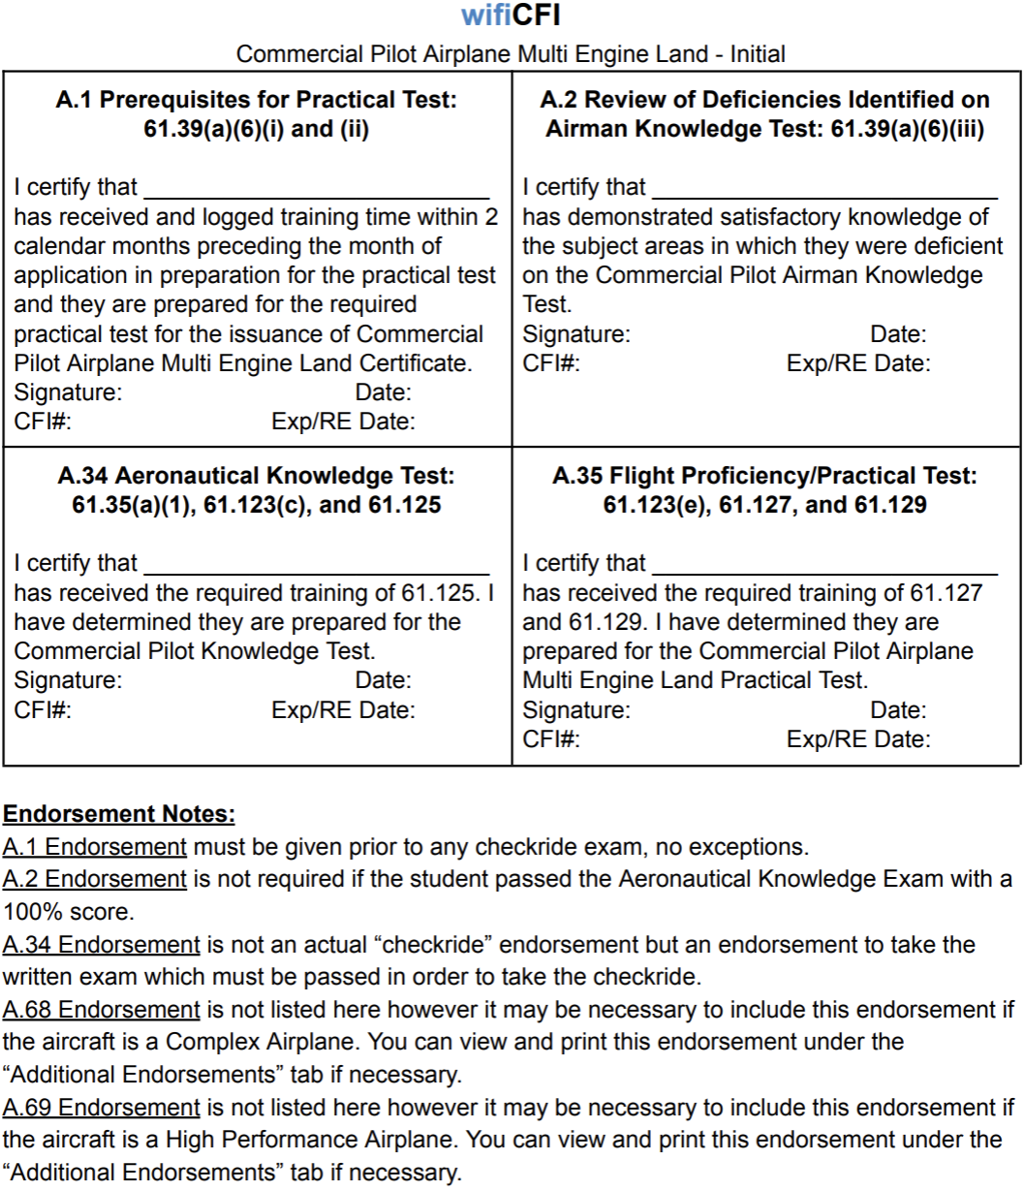
COMMERCIAL AMEL ADD-ON
IACRA or 8710-1 | Completed and Submitted
English Proficient | Speak, read, write & understand
Minimum age | 18
Photo ID | Government issued, current, verify name and address matches 8710-1
Citizenship | If dual citizenship, call the FSDO, Country of citizenship is especially important on IACRA.
Pilot Certificate | Valid, signed, must hold Instrument Rating or Concurrently Enrolled for 141
Medical | 3rd class, note limitations, Basic Med
141 Graduation Certificate | Valid within 60 days – Cannot be extended with a Discontinuance.  One certificate from the UNO ground school and another Carver Aero/Oracle
English Proficient | Speak, read, write & understand
61 COMMERCIAL AMEL ADD-ON  AERONAUTICAL EXPERIENCE REQUIREMENTS |  | 141 COMMERCIAL AMEL ADD-ON  AERONAUTICAL EXPERIENCE REQUIREMENTS
Received and logged ground training from an MEI, (with or without a CFII) or completed a home-study course |  | Received and logged ground training from an MEI,  (with or without a CFII)
Received and logged flight training from an MEI, (with or without a CFII) and no minimum time requirements |  | Received and logged flight training from an MEI, (with or without a CFII) and no minimum time requirements
Note: ACS - AOA X. Multiengine Operations Task C. and Task D must be tested if the Applicant holds Instrument Airplane privileges.  An Applicant is prohibited from receiving the limitation, “Airplane Multiengine VFR Only”, if they hold an Instrument Airplane Rating before this Practical Test.  Reference: Appendix 7 – Commercial ACS. |  | Note: ACS - AOA X. Multiengine Operations Task C. and Task D must be tested if the Applicant holds Instrument Airplane privileges.  An Applicant is prohibited from receiving the limitation, “Airplane Multiengine VFR Only”, if they hold an Instrument Airplane Rating before this Practical Test.  Reference: Appendix 7 – Commercial ACS.

Endorsements Required: Must match AC61-65J. See https://www.wificfi.com/endorsements

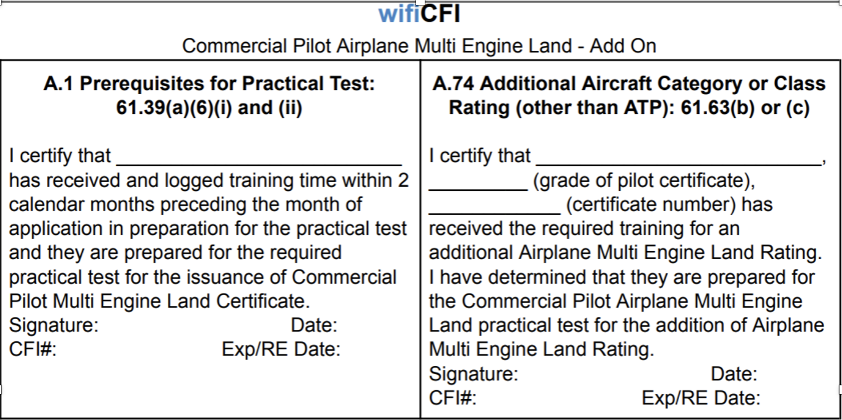

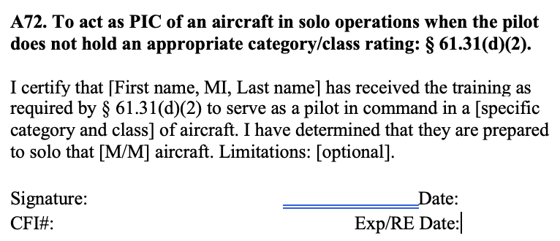
COMMERCIAL ASEL ADD ON
IACRA or 8710-1 | Completed and Submitted
English Proficient | Speak, read, write & understand
Minimum age | 17
Photo ID | Government issued, current, verify name and address matches 8710-1
Citizenship | If dual citizenship, call the FSDO, Country of citizenship is especially important on IACRA.
Pilot Certificate | Valid, signed, must hold Instrument Rating or Concurrently Enrolled for 141
Medical | 3rd class, note limitations, Basic Med
Knowledge Test | Passing score, within last 24 months
141 Graduation Certificate | Valid within 60 days – Cannot be extended with a Discontinuance.  One certificate from the UNO ground school and another Carver Aero/Oracle
§61 COMMERCIAL AMEL ADD-ON  AERONAUTICAL EXPERIENCE REQUIREMENTS |  | §141 COMMERCIAL AMEL ADD-ON  AERONAUTICAL EXPERIENCE REQUIREMENTS
Received and logged ground training from an MEI, (with or without a CFII) or accomplished a home-study course |  | Received and logged ground training from a MEI, (with or without a CFII) or accomplished a home-study course
Received and logged flight training from an MEI, (with or without a CFII) and no minimum time requirements |  | Received and logged flight training from an MEI, (with or without a CFII) and no minimum time requirements
Note: ACS - AOA X. Multiengine Operations Task C. and Task D must be tested if the Applicant holds Instrument Airplane privileges. An Applicant is prohibited from receiving the limitation ”Airplane Multiengine VFR Only”. Reference: Appendix 7. |  | Note: ACS - AOA X. Multiengine Operations Task C. and Task D must be tested if the Applicant holds Instrument Airplane privileges. An Applicant is prohibited from receiving the limitation ”Airplane Multiengine VFR Only”. Reference: Appendix 7.

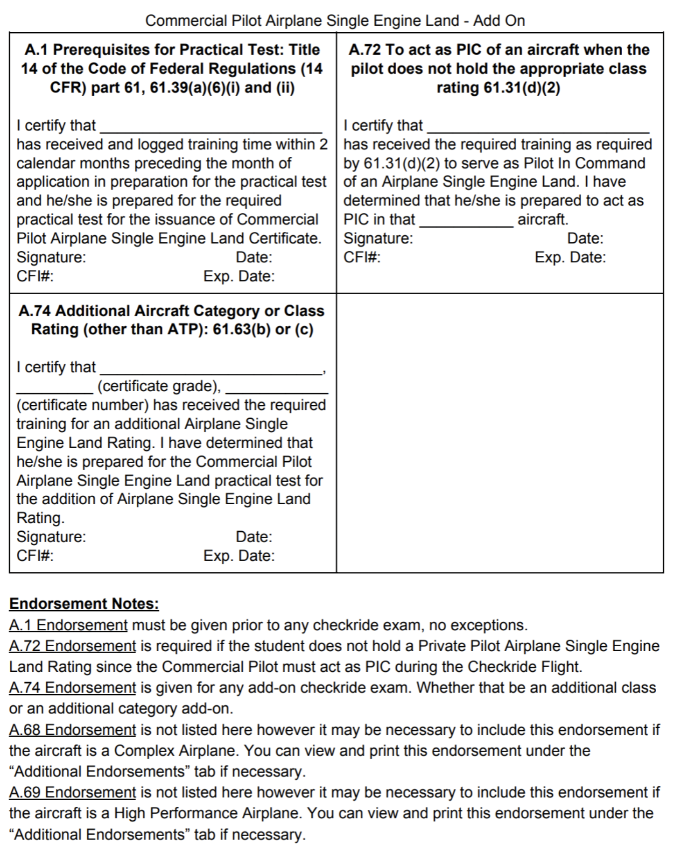

CFI INITIAL ASEL
IACRA or 8710-1 | Completed and Submitted
Photo ID | Government issued, current, verify name and address matches 8710-1
Minimum age | 18
Pilot Certificate | Valid Commercial with an Instrument Rating or ATP, Signed
Medical | 3rd class, note limitations
Knowledge Test Results  FOI and FIA | Valid within 24 months  FOI Knowledge Exam Not Required if using exemption for certified teachers
141 Graduation Certificate | Valid within 60 days
English Proficient | Speak, read, write & understand
61/141 AERONAUTICAL
EXPERIENCE REQUIREMENTS
15 hours PIC in Category and Class of aircraft sought
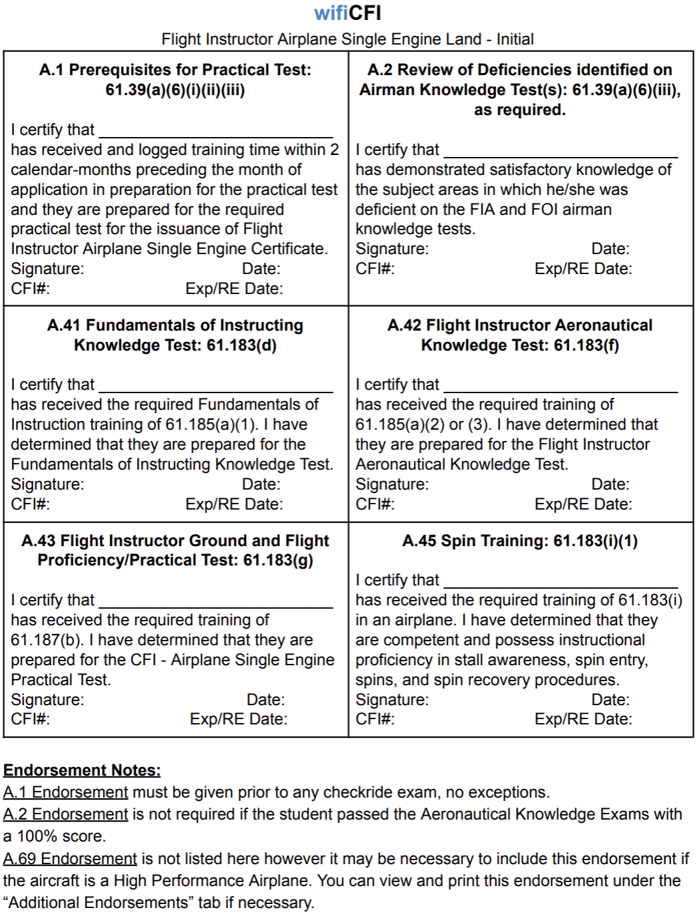
Additionally, Recommending CFI, must meet the 61.195(h). Note: A.41 and A.42 are required for the Practical Test and must be in the Applicant’s Logbook to satisfy the ground training requirements. Although, NOT Required for Testing Center authorization to take the FIA/FOI.

CFI INITIAL AMEL
IACRA or 8710-1 | Completed and Submitted
Photo ID | Government issued, current, verify name and address matches 8710-1
Minimum age | 18
Pilot Certificate | Valid Commercial with an Instrument Rating or ATP, Signed
Medical | 3rd class, note limitations
Knowledge Test Results  FOI and FIA | Valid within 24 months  FOI Knowledge Exam Not Required if using exemption for certified teachers
141 Graduation Certificate | Valid within 60 days
English Proficient | Speak, read, write & understand
61/141 AERONAUTICAL
EXPERIENCE REQUIREMENTS
15 hours PIC in Category and Class of aircraft sought
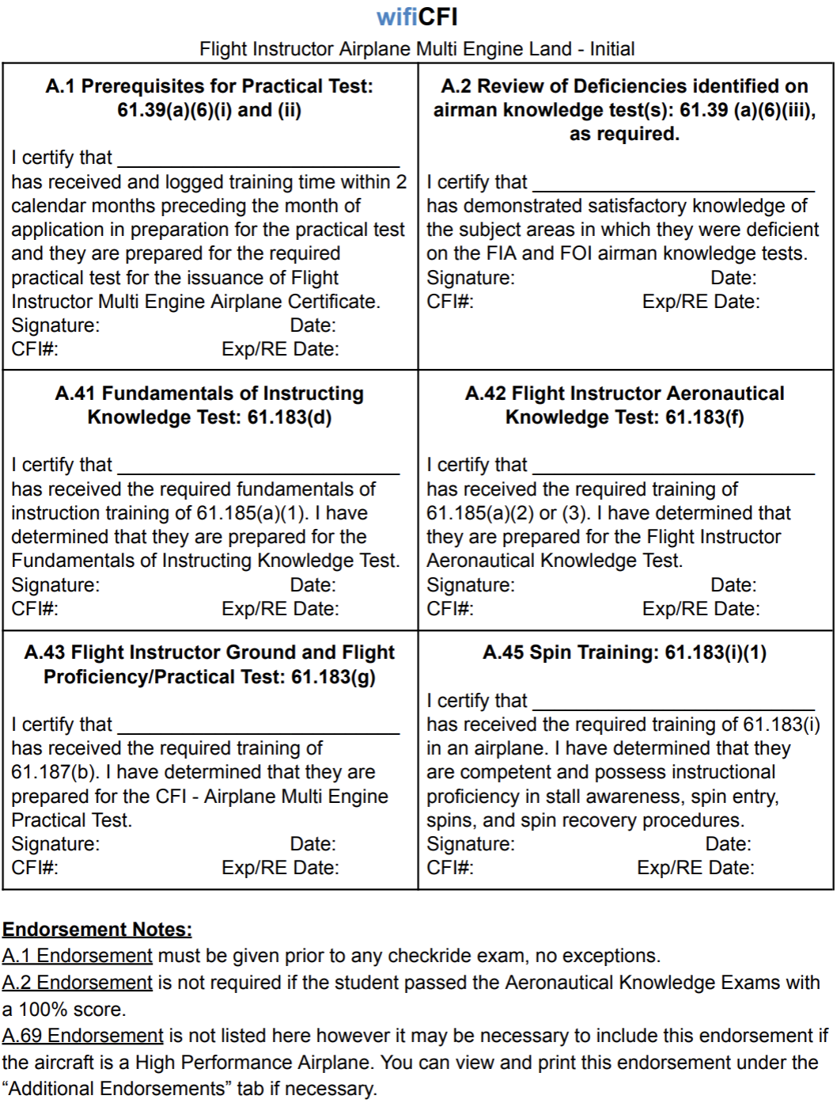
Additionally, Recommending CFI, must meet the 61.195(h).
Note: A.41 and A.42 are required for the Practical Test and must be in the Applicant’s Logbook to satisfy the ground training requirements. Although, NOT Required for Testing Center authorization to take the FIA/FOI Knowledge Tests.

CFI ASEL ADD ON
IACRA or 8710-1 | Completed and Submitted
Photo ID | Government issued, current, verify name and address matches 8710-1
Minimum age | 18
Pilot Certificate | Valid Commercial with an Instrument Rating or ATP, Signed
Medical | 3rd class, note limitations
Knowledge Test Results  FOI and FIA | Valid within 24 months  FOI Knowledge Exam Not Required if using exemption for certified teachers
141 Graduation Certificate | Valid within 60 days
English Proficient | Speak, read, write & understand
61/141 AERONAUTICAL EXPERIENCE REQUIREMENTS
15 hours PIC in Category and Class of aircraft sought

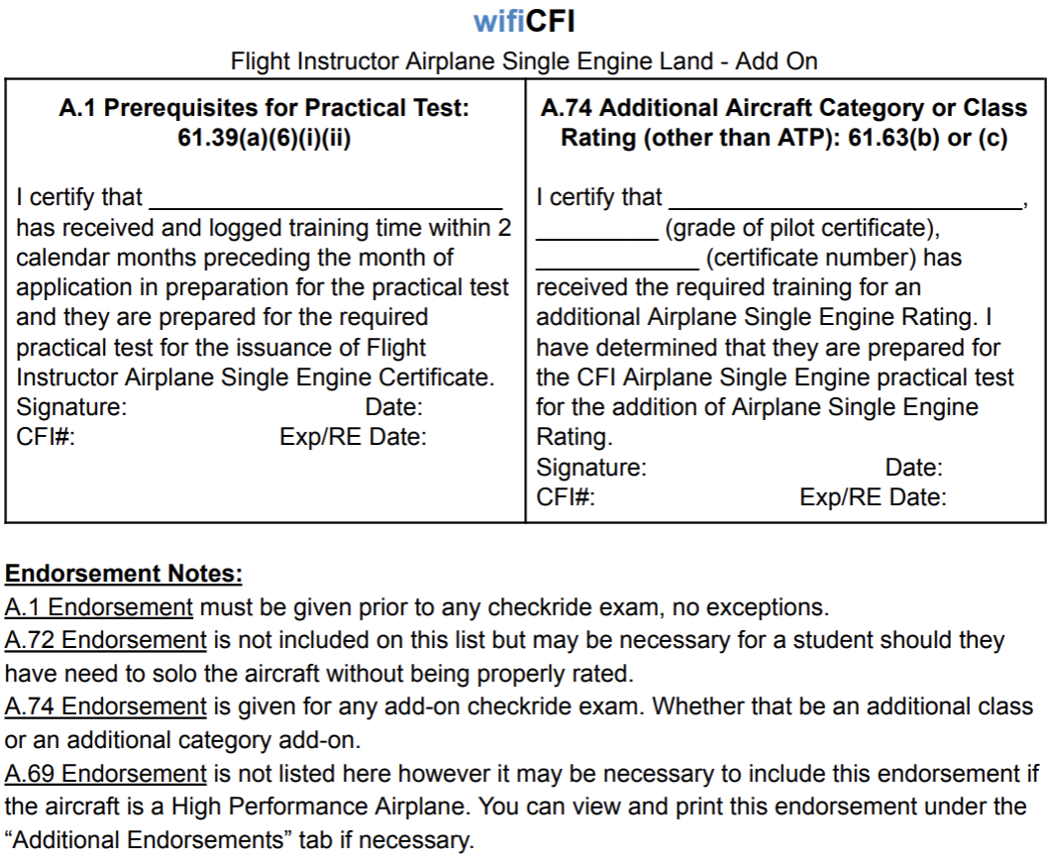

CFII ADD-ON
IACRA or 8710-1 | Completed and Submitted
Photo ID | Government issued, current, verify name and address matches 8710-1
Minimum age | 18
Pilot Certificate | Commercial with an Instrument Rating or ATP, Signed, valid
Medical | 3rd class, note limitations
Knowledge Test Results  FOI and FIA | Valid within 24 months Note: No endorsement required to take the Flight Instructor Instrument written knowledge test. Does not exist.  FOI Knowledge Exam Not Required if using exemption for certified teachers
141 Graduation Certificate | Valid within 60 days
English Proficient | Speak, read, write & understand
AERONAUTICAL EXPERIENCE REQUIREMENTS
15 hours PIC in category and class aircraft sought
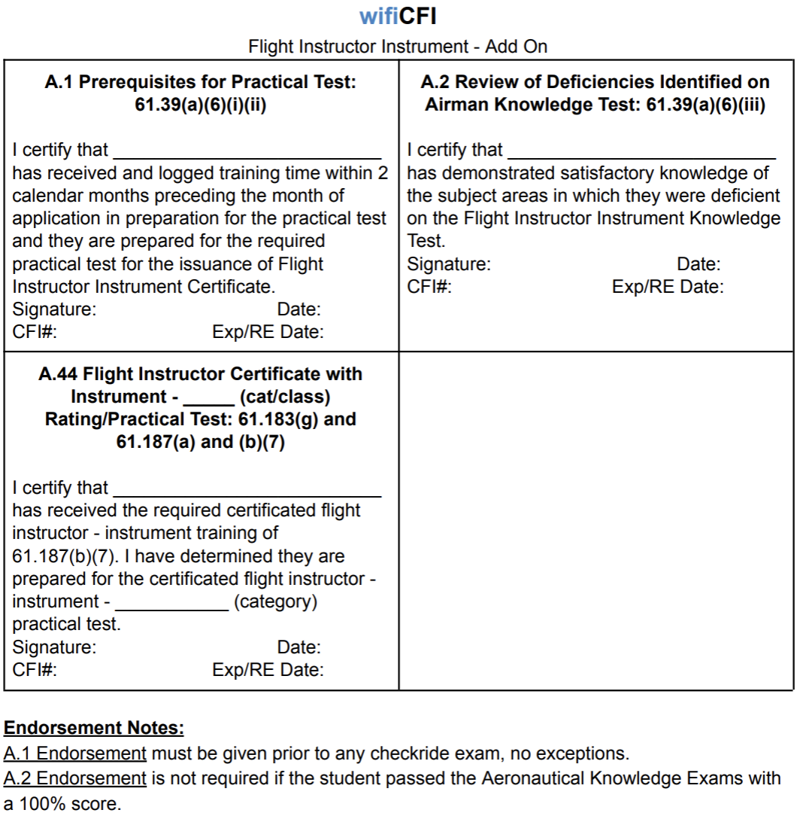

MEI ADD-ON
IACRA or 8710-1 | Completed and Submitted
Photo ID | Government issued, current, verify name and address matches 8710-1
Minimum age | 18
Pilot Certificate | CFI, signed, valid
Medical | 3rd class, note limitations
141 Graduation Certificate | Valid within 60 days
English Proficient | Speak, read, write & understand
AERONAUTICAL EXPERIENCE REQUIREMENTS
15 hours PIC in Category and Class of aircraft sought

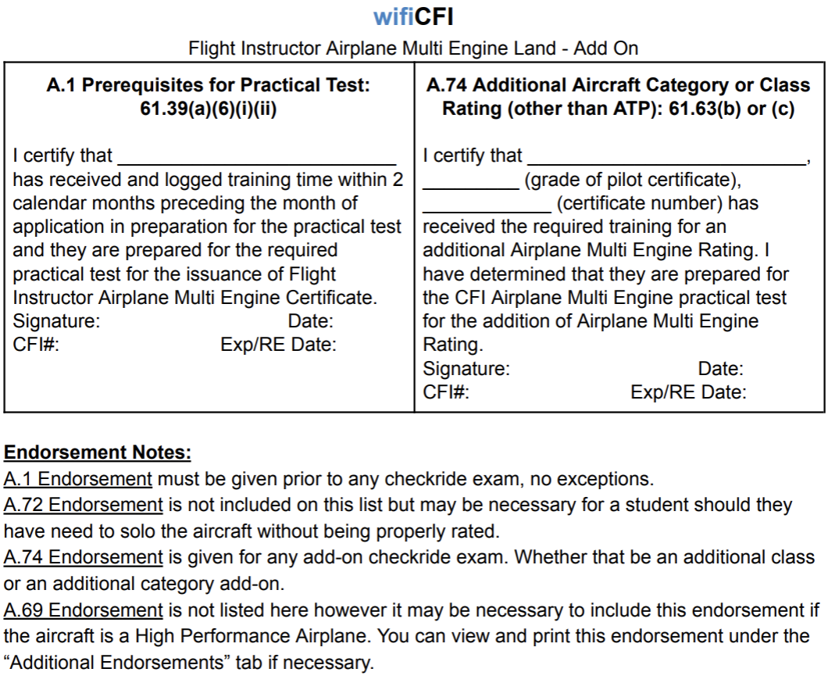

CFI REINSTATEMENT
IACRA or 8710-1 | Completed and Submitted
Photo ID | Government issued, current, verify name and address matches 8710-1
Minimum age | 18
Pilot Certificate | CFI, signed, valid
Medical | 3rd class, note limitations
141 Graduation Certificate | Valid within 60 days
English Proficient | Speak, read, write & understand

Note: No Endorsements Required for a Reinstatement if based on a previously held CFI Certificate or Rating.

FIRE - CFI RENEWAL
§61.197 Renewal requirements for flight instructor certification.
- (a) A person who holds a flight instructor certificate that has not expired may renew that flight instructor certificate by—
- (1) Passing a practical test for—
- (i) One of the ratings listed on the current flight instructor certificate; or
- (ii) An additional flight instructor rating; or
- (2) Submitting a completed and signed application with the FAA and satisfactorily completing one of the following renewal requirements—
- (i) A record of training students showing that, during the preceding 24 calendar months, the flight instructor has endorsed at least 5 students for a practical test for a certificate or rating and at least 80 percent of those students passed that test on the first attempt.
- (ii) A record showing that, within the preceding 24 calendar months, the flight instructor has served as a company check pilot, chief flight instructor, company check airman, or flight instructor in a part 121 or part 135 operation, or in a position involving the regular evaluation of pilots.
Who is a “Regular Evaluator” for renewal under “Duties and Responsibilities”?
Part 121 or 135 Check Airman
Chief Flight Instructor
Company Check Pilot in a Part 121 or Part 135 Operation
A Part 121 or 135 Flight Instructor
A PIC in a multiple crew under Parts 121, 135, 91-K, 125
Military pilot of multiple crew aircraft
Military instructor pilots and examiners who evaluate airmen
FAA DPE’s and PPE’s
Note: 141 Company Check Pilot is not allowed to renew based on “Duties and Responsibilities.”
What is a “Record?” Possible options:
Company letter
Company training record
Documented proficiency checks

An FO alone does not meet the intent of 61.197(b)(2)(ii) or the 8900.1 guidance. Previous guidance maybe gave some wiggle room
for a Part 121 pilot, but it was gray. The regulation and the guidance are now clear what is needed to use a Part 121 position. I don't
see how an FO has any evaluation duties.
b) A record showing that, within the preceding 24 calendar months, the flight
instructor has served in one of the following positions, and has knowledge of its current pilot
training standards and FAA certification standards applicable to the duties and
responsibilities of:
. A company check pilot,
. A chief flight instructor,
. A company check airman,
. A flight instructor in a 14 CFR part 121 or 135 operation, or
. A person in a position involving the regular evaluation of pilots
Feel free to send this to the applicant, and the Chief Pilot. I would encourage the Chief Pilot to either update this or to reach out with further interpretation or guidance from an FAA standpoint.
- (iii) A graduation certificate showing that, within the preceding 3 calendar months, the person has successfully completed an approved flight instructor refresher course consisting of ground training or flight
training, or a combination of both.
- (iv) A record showing that, within the preceding 24 months from the month of application, the flight instructor passed an official U.S. Armed Forces military instructor pilot or pilot examiner proficiency check in an aircraft for which the military instructor already holds a rating or in an aircraft for an additional rating.
Military Instructor - Establish criteria met thru review of pertinent military records
  - Each branch of service has a unique form to establish pilot proficiency and checking
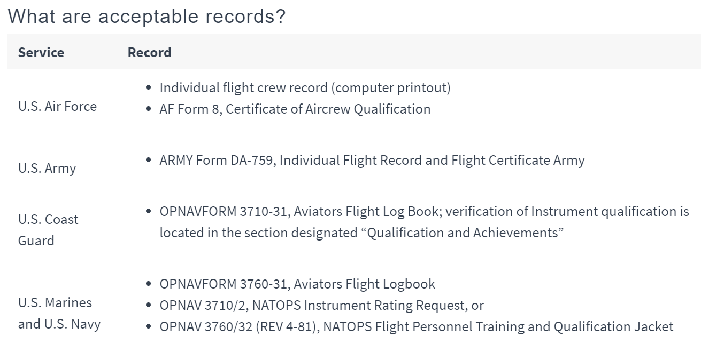 Other Renewal Options
A holder of a current flight instructor certificate who has been designated as a Master CFI by the National Association of Flight Instructors (NAFI) within the current renewal period may renew his or her flight instructor certificate.
NOTE: Not addressed specifically in §61.197. Considered a DUTIES AND RESPONSIBITIES option.
A holder of a current flight instructor certificate who serves as a flight instructor in the FAA’s Pilot Proficiency Program (WINGS) and gives flight training to qualify pilots for a phase proficiency award may renew his or her certificate.

NOTE: Not addressed specifically in §61.197. Considered a DUTIES AND RESPONSIBITIES option.
Special criteria apply. Consult Order 8900.1, par. 5-504, B3)
WINGS – PILOT PROFICIENCY PROGRAM RENEWAL
Renewal on the Basis of Acquaintance: The FAA never intended or permitted that an applicant’s flight instructor certificate be renewed merely on the basis of acquaintance. FAA policy has always required evidence
of the applicant’s employment, which should clearly show that applicants are in a position involving the regular evaluation of pilots, or to have personal knowledge of an applicant’s flight instructing capabilities and qualities before renewing that applicant’s flight instructor certificate.
IACRA: Processing CFI renewals via paper is discouraged. If, however, that is the only option follow the guidance of the Managing Specialist.
Since all DPE’s should be familiar with the IACRA process, executing a CFI renewal is not much different than any other certification action. If necessary, access the IACRA TRAINING SERVER and work through a CFI
renewal based upon DUTIES AND RESPONSIBILITIES or other methods of renewal. https://iacratraining.faa.gov/
DMS: Do not forget that processing a CFI Renewal requires a DMS “Pre-approval” and “Post Activity Report.”
OVERSIGHT: As a method of quality assurance, you can expect the FAA to observe compliance with appropriate guidance contained in this presentation and relevant orders upon which this presentation is based

A Certified Flight Instructor (CFI) can renew their certificate by completing a Flight Instructor Refresher Course (FIRC), which is now considered the primary method to maintain currency as CFI certificates no longer have an expiration date, but instead
require meeting recent experience requirements that can be fulfilled by taking a FIRC within a 3-month grace period if needed.
Key points about CFI renewal and FIRC:
- No expiration date:
As of recent FAA rule changes, CFI certificates no longer have an expiration date.
- Recent experience requirements:
To maintain CFI privileges, pilots must meet recent experience requirements every 24 months.
- FIRC for renewal:
Completing a FIRC is one way to meet these recent experience requirements and effectively renew your CFI certificate.
- Grace period:
If your recent experience lapses, you can still reinstate your CFI status by completing
a FIRC within a 3-month grace period.

RESTRICTED ATP LIMITATION REMOVAL
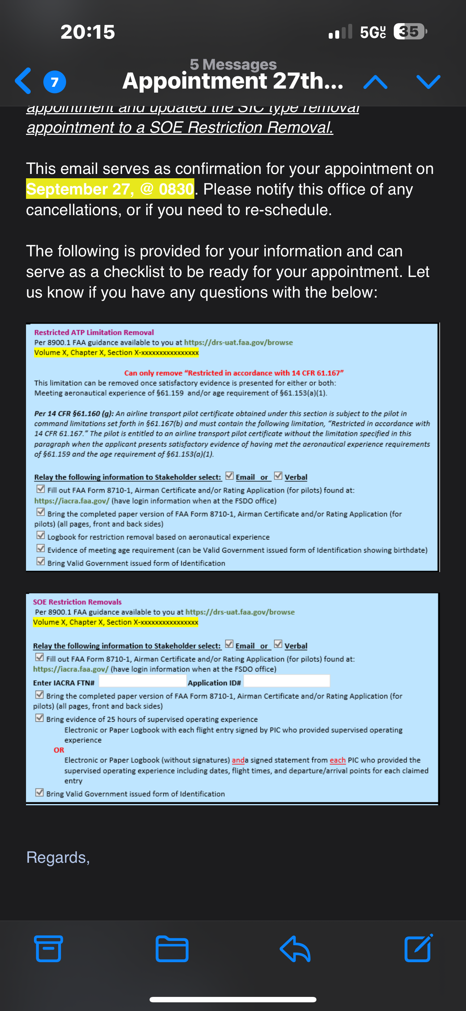

COMMERCIAL ASEL – COMMERCIAL ROTORCRAFT TRANSITION
IACRA or 8710-1 | Completed and Submitted
Photo ID | Government issued, current, verify name and address matches 8710-1
Minimum age | 18
Pilot Certificate | Signed, valid
Medical | 3rd class, note limitations
English Proficient | Speak, read, write & understand

UNDER CONSTRUCTION

Note: Pilots have the choice to acquire the Private Pilot ASEL first, then build 50 hrs of PIC as a Private Pilot while acquiring the Commercial ASEL cross country requirement. One reason for acquiring the Private ASEL first would be to allow the pilot to carry passengers during some of their 50 hrs of PIC flight experience.

Rotorcraft Commercial Instrument Rated Pilot to ASEL Private Pilot
Would not transfer the Instrument Rating. A separate Instrument Airplane Rating Practical Test would be required.
Another Practical Test to add the Instrument Rating will need to take place in order to remove the limitation,
“The carriage of passengers for hire in airplanes on cross country flights in excess of 50 nautical
miles or at night is prohibited.”
Knowledge Test Not Required
61.107 (a)(b)(1) – All items required.
61.109 Aeronautical Experience
20 hrs of Flight Training
10 hrs of Solo Flight Training – 61.109 Aeronautical Experience
------------------------------------------------------------------------------------
30 hrs Total Flight Training
§61.109 Aeronautical experience.

- For an airplane single-engine rating. Except as provided in paragraph (k) of this section,
- a person who applies for a private pilot certificate with an airplane category and single-engine class rating must log at least 40 hours of flight time (any aircraft) that includes at least (20 hours
- of flight training from an authorized instructor and 10 hours of solo flight training in the
- areas of operation listed in §61.107(b)(1)-This suggests the training needs to be Airplane single engine specific.)
(1) 3 hours of cross-country flight training in a single-engine airplane;
(2) Except as provided in §61.110 of this part, 3 hours of night flight training in a single-engine airplane that includes—
(i) One cross-country flight of over 100 nautical miles total distance; and
(ii) 10 takeoffs and 10 landings to a full stop (with each landing involving a flight in the traffic pattern) at an airport.

(3) 3 hours of flight training in a single-engine airplane on the control and maneuvering of an airplane solely by reference
to instruments, including straight and level flight, constant airspeed climbs and descents, turns to a heading, recovery from unusual flight attitudes, radio communications, and the use of navigation systems/facilities and radar services appropriate
to instrument flight;

(4) 3 hours of flight training with an authorized instructor in a single-engine airplane in preparation for the practical test, which must have been performed within the preceding 2 calendar months from the month of the test; and
(5) 10 hours of solo flight time in a single-engine airplane, consisting of at least—
(i) 5 hours of solo cross-country time;
(ii) One solo cross country flight of 150 nautical miles total distance, with full-stop landings at three points, and one segment of the flight consisting of a straight-line distance of more than 50 nautical miles between the takeoff and landing locations; and
(iii) Three takeoffs and three landings to a full stop (with each landing involving a flight in the traffic pattern) at an airport with an operating control tower.

PRIVATE PILOT ADD from HELICOPTER PILOT

To be eligible for a Private Pilot Airplane Add-On, a person must:
- Obtain a minimum of 30 flight hours, which must include a minimum 20 hours of dual flight and a minimum 10 hours of solo flight
- Complete Ground School (Approximately 10 hours)
- Pass FAA practical examination
- Must complete the training and have the applicable aeronautical experience.
- Must have logbook or training record endorsement from an authorized instructor attesting that you were found competent in the appropriate aeronautical knowledge areas and proficient in the appropriate areas of operation.
- Must pass the practical test (Written not applicable, unless license expired).
- Need not take any additional knowledge test, provided applicant holds an airplane, rotorcraft, power-lift, weight-shift-control aircraft, powered parachute, or airship rating at that pilot certificate level.
The training specified as must do in FAR AIM 61.109 to accomplish the Additional Fixed Wing Aircraft Category rating from FAR AIM 61.63, designates the FAA minimum as described below:
- 3 hours of cross country
- 3 hours of flight training on the control and maneuvering of the single engine aircraft
- 3 hours flight training by authorized instructor
- 10 hours of solo cross country time
- At least 5 hours include solo cross country time:
- One solo to include 150 nautical miles with full stop landing at three points.
- Three takeoff’s and three landings to full stop involving flight in the traffic pattern at an airport with an operating tower.

BASIC GROUND INSTRUCTOR
IACRA or 8710-1 | Completed and Submitted
Photo ID | Government issued, current, verify name and address matches 8710-1
Minimum age | 18
Pilot Certificate | CFI, signed, valid
Medical | 3rd class, note limitations
English Proficient | Speak, read, write & understand
Knowledge Test Results  FOI and BGI | Valid within 24 months Note: No endorsement required to take the Ground Instructor written knowledge test. Does not exist.  If CFI is not held, then the FOI Knowledge Exam is Required. Not Required if using exemption for certified teachers.

ADVANCED GROUND INSTRUCTOR
IACRA or 8710-1 | Completed and Submitted
Photo ID | Government issued, current, verify name and address matches 8710-1
Minimum age | 18
Pilot Certificate | CFI, signed, valid
Medical | 3rd class, note limitations
English Proficient | Speak, read, write & understand
Knowledge Test Results  FOI and AGI | Valid within 24 months Note: No endorsement required to take the Advanced Ground Instructor written knowledge test. Does not exist.  If CFI is not held, then the FOI Knowledge Exam is Required. Not Required if using exemption for certified teachers.

INSTRUMENT GROUND INSTRUCTOR
IACRA or 8710-1 | Completed and Submitted
Photo ID | Government issued, current, verify name and address matches 8710-1
Minimum age | 18
Pilot Certificate | CFI, signed, valid
Medical | 3rd class, note limitations
English Proficient | Speak, read, write & understand
Knowledge Test Results  FOI and IGI | Valid within 24 months Note: No endorsement required to take the Instrument Ground Instructor written knowledge test. Does not exist.  If CFI is not held, then the FOI Knowledge Exam is Required. Not Required if using exemption for certified teachers.

GOLD SEAL FLIGHT INSTRUCTOR
NOT AUTHORIZED – APPLICANT MUST CONTACT FSDO

ATP AMEL INITIAL - UNRESTRICTED
IACRA or 8710-1 | Completed and Submitted
Photo ID | Government issued, current, verify name and address matches 8710-1
Minimum age | 23
Pilot Certificate | Commercial AMEL, signed, valid
Medical | 3rd class, note limitations
CTP Graduation Certificate | Valid
English Proficient | Speak, read, write & understand
AERONAUTICAL EXPERIENCE REQUIREMENTS 61.159
1500 Total Time
500 hours cross-country
100 hours night
75 hours instrument
250 hours PIC
50 hours of multiengine
No Recommending Endorsement Required
No Ground Training Documents Required – CTP Graduation Certificate suffices
May take the Practical Test in a Light Twin or FFS. BATD and AATD prohibited for testing

The R-ATP allows a pilot to serve as an airline first officer before reaching the requisite 1,500 hours for an unrestricted ATP. The R-ATP also requires that a pilot be at least 21 years of age and successfully complete a checkride. The R-ATP, in lieu of the 1,500 hour requirement, offers credit for specialized training received as part of a collegiate aviation curriculum or through the military. The R-ATP eligibility requirements are fully defined in § 61.160 and the options for R-ATP minimum experience are:
- 750 hours for military pilots
- 1,000 hours for college graduates who possess a bachelor’s degree with an aviation major from an approved school
- 1,250 hours for college graduates possessing an associate degree with an aviation major from an approved school
For each of the R-ATP options, the majority of total flight experience must have been obtained while enrolled in the approved program. It’s worth noting that simply graduating from a program that confers a degree does not automatically grant eligibility for the R-ATP. Each school that desires to certify its graduates for the R-ATP must apply for and receive approval from the FAA and must meet criteria outlined in Advisory Circular 61-139.
R-ATP is a good option for flight instructors who may not possess 500 hours cross-country experience.
Considered in the ATP regulations is a category of pilots who may possess the 1,500 hours of total pilot time required for an unrestricted ATP, but fall short of the requisite 500 hours of cross-country experience (e.g. flight instructors). These pilots, as long as they possess at least 200 hours of cross-country time, and otherwise meet ATP experience requirements, are also eligible to apply for the R-ATP.
When transitioning from a R-ATP to an unrestricted ATP, an FAA inspector can remove R-ATP limitations and issue a full ATP with paperwork only. The applicant must present evidence that he has met the ATP age requirement (23) and the aeronautical experience requirements of § 61.159. The applicant then must complete section III – Record of Pilot Time, on a pilot application (form 8710) to be issued the unrestricted ATP.
ATP-CTP requires training in a full motion flight simulator.
Also required of ATP certification is the completion of an FAA-approved Airline Transport Pilot Certification Training Program (ATP-CTP) PRIOR to taking the FAA written exam for multiengine ATP. ATP-CTP is a 40 hour course – 30 hours of ground school and 10 hours of simulator training – intended to prepare the applicant to operate safely in those operations that require an ATP. Of the 10 hours of simulator training, six (6) hours must be completed in a Level C or higher full flight simulator that represents a multiengine, turbine airplane with a maximum takeoff weight of at least 40,000 pounds, rendering many corporate aircraft ineligible.
The ATP CTP serves as a prerequisite for the multiengine ATP written exam and includes training in:
ATP-CTP training may be included in some airline new-hire programs.
All pilots taking the ATP knowledge test are required to present a graduation certificate certifying the completion of an ATP-CTP before taking the written test. Written tests for multiengine ATP are valid for 60 calendar months (much longer than the 24 months granted for other written exams). The ATP-CTP graduation certificate itself does not expire
It’s worth noting that the ATP-CTP itself does not prepare you for the FAA written exam. It’s only a pre-requisite for the written exam. It would be wise to select a trusted training source for dedicated written test preparation independent of your ATP-CTP training.

ATP ASEL ADD ON
IACRA or 8710-1 | Completed and Submitted
Photo ID | Government issued, current, verify name and address matches 8710-1
Minimum age | 23
Pilot Certificate | ATP AMEL, signed, valid
Medical | 3rd class, note limitations
Knowledge Test | Not Required for Add-On. Required for Initial ATP Applicants only
English Proficient | Speak, read, write & understand
Note: No Recommending CFI Endorsements Required

RECREATIONAL PILOT ASEL
IACRA or 8710-1 | Completed and Submitted
Photo ID | Government issued, current, verify name and address matches 8710-1
Minimum age | 17
Pilot Certificate | Signed, valid
Medical | 3rd class, note limitations, Basic Med
Knowledge Test | Passing score, within last 24 months
English Proficient | Speak, read, write & understand
AERONAUTICAL EXPERIENCE REQUIREMENTS § 61
30 hrs Total Flight Time
15 hrs Dual Flight Training Received
2 hours of flight training enroute to an airport that is located more than 25 nm from the airport where the applicant normally trains, which includes at least 3 takeoffs/landings at that airport.
3 hrs Solo Flight Time
1 Solo XC of 150 nm or greater with full stop landings at each airport. One 50+ nm segment
3 hrs Dual within the preceding 2 calendar months of application date (may be from other than recommending CFI)

A.25 Aeronautical knowledge test: §§ 61.35(a)(1), 61.96(b)(3), and 61.97(b).
I certify that [First name, MI, Last name] has received the required training of § 61.97(b). I have determined that
[he or she] is prepared for the [name of] knowledge test.
A.26 Flight proficiency/practical test: §§ 61.96(b)(5), 61.98(a) and (b), and 61.99. The endorsement for a
practical test is required in addition to the § 61.39 endorsements provided in paragraphs A.1 and A.2.
I certify that [First name, MI, Last name] has received the required training of §§ 61.98(b) and 61.99. I have determined that [he or she] is prepared for the [name of] practical test.
A.27 Recreational pilot to operate within 50 NM of the airport where training was received: § 61.101(b).
I certify that [First name, MI, Last name] has received the required training of § 61.101(b). I have determined that
[he or she] is competent to operate at the [name of airport].
A.28 Recreational pilot to act as pilot in command on a flight that exceeds 50 NM of the departure airport: § 61.101(c). I certify that [First name, MI, Last name] has received the required cross-country training of § 61.101(c). I have determined that [he or she] is proficient in cross-country flying of part 61 subpart E.
A.29 Recreational pilot with less than 400 flight hours and no logged pilot in command time within the preceding 180 calendar-days: § 61.101(g).
I certify that [First name, MI, Last name] has received the required 180-day recurrent training of § 61.101(g) in a [make and model] aircraft. I have determined [him or her] proficient to act as pilot in command of that aircraft.
A.30 Recreational pilot to conduct solo flights for the purpose of obtaining an additional certificate or rating while under the supervision of an authorized flight instructor: § 61.101(j).
I certify that [First name, MI, Last name] has received the required training of § 61.87 in a [make and model]
aircraft. I have determined [he or she] is prepared to conduct a solo flight on [date] under the following conditions: [List all conditions which require endorsement (e.g., flight which requires communication with air traffic control,
flight in an aircraft for which the pilot does not hold a category/class rating, etc.).]
A.31 Class B, C, or D airspace, at an airport located in Class B, C, or D airspace, or to, from, through, or at
an airport having an operational control tower: § 61.101(d).
I certify that [First name, MI, Last name] has received the required training of § 61.101(d). I have determined [he
or she] is proficient to conduct operations in Class B, C, or D airspace, at an airport located in Class B, C, or D airspace, or to, from, through, or at an airport having an operational control tower.

SPORT PILOT ASEL
IACRA or 8710-1 | Completed and Submitted
Photo ID | Government issued, current, verify name and address matches 8710-1
Minimum age | 17
Pilot Certificate | Signed, valid
Medical | 3rd class, note limitations, Basic Med
Knowledge Test | Passing score, within last 24 months
English Proficient | Speak, read, write & understand
AERONAUTICAL EXPERIENCE REQUIREMENTS § 61.313 Subpart J
20 hrs Total Flight Time
15 hrs Dual Flight Training Received
2 hrs of cross-country flight training
One solo cross-country flight of at least 75 nautical miles total distance, with a full-stop landing at a minimum of two points and one segment of the flight consisting of a straight-line distance of at least 25 nautical miles between the takeoff and landing locations
5 hrs Solo Flight Time
10 Take offs and Landings (with each landing involving a flight in the traffic pattern)
2 hrs Dual within the preceding 2 calendar months of application date
(may be from other than recommending CFI)
POSSIBLY REQUIRED
A.22 Class B, C, or D airspace, at an airport located in Class B, C, or D airspace, or to, from, through, or at an airport having an operational control tower: § 61.325.
I certify that [First name, MI, Last name] has received the required training of § 61.325. I have determined [he or she] is proficient to conduct operations in Class B, C, or D airspace, at an airport located in Class B, C, or D airspace, or to, from, through, or at an airport having an operational control tower.
A.23 Light-sport aircraft that has a maximum speed in level flight with maximum continuous power (VH) less than or equal to 87 Knots Calibrated Airspeed (KCAS): § 61.327.
I certify that [First name, MI, Last name] has received the required training required in accordance with § 61.327(a) in a [make and model] aircraft. I have determined [him or her] proficient to act as pilot in command of a light-sport aircraft that has a VH less than or equal to 87 KCAS.
A.24 Light-sport aircraft that has a VH greater than 87 KCAS: § 61.327.
I certify that [First name, MI, Last name] has received the required training required in accordance with § 61.327(b) in a [make and model] aircraft. I have determined [him or her] proficient to act as pilot in command of a light-sport aircraft that has a VH greater than 87 KCAS.

RETESTING AFTER FAILURE
A new IACRA Application or Paper 8710-1 Application must be created.
The First Attempt Recommending Instructor is not required to conduct the additional retraining.
Any CFI who is authorized may conduct the additional training and Endorse the Applicant for the Retest.
The additional training may occur in a flight simulator, such as an approved ATD. Using a flight simulator must be jointly agreed upon by the Recommending CFI and DPE involved. The training must be considered a reasonable means for conducting the additional training required to sufficiently train the Applicant to meet FAA Standards.

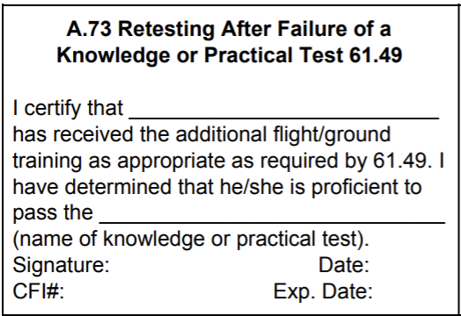
FOREIGN PILOT ELIGIBILITY NOTES

1. It appears the airman is adding an instrument airplane US test passed rating to his 61.75 certificate as he does not hold an unrestricted private pilot certificate.
2. Please correct the temporary certificate by adding: A. "Private pilot - Foreign based" in Section IX;
B. ISSUED ON BASIS OF AND VALID ONLY WHEN ACCOMPANIED BY TAIWAN PILOT LICENSE NUMBER(S) P00125 P304314.
ALL LIMITATIONS AND RESTRICTIONS ON THE TAIWAN PILOT LICENSE APPLY; .C Instrument airplane U.S Test Passed"
3. Anytime an applicant is applying for a US pilot certificate on the basis of holding a foreign license (even if a practical test was administered), the applicant must first complete a Form for Verification of Authenticity of
Foreign license, Rating, and Medical. Our records show the airman's last verification letter has expired.
4. Section IID must be completed anytime the applicant is applying for a US pilot certificate on the basis of holding a foreign license (even if a practical test was administered). (Order 8900.1, Volume 5, Chapter 2, Section 14).
FLIGHT SIMULATOR NOTES

FLIGHT SIMULATOR CREDIT CHART
 | 61 | 141 | 61 | 141
 | BATD | BATD | AATD | AATD
PRIVATE | 2.5 | 2.5 | 2.5 | 15% of Training
INSTRUMENT | 10 | 10 | 20 | 40% of Training
COMMERCIAL | None | None | 50 | 20% of Training
CFI |  |  |  | 10% of Training
CFII |  |  |  | 5% of Training
ATP | None | None | 25 | 25% of Training

Note: Full Flight Simulators reference 141.
Flight School must possess an LOA from their managing FAA FSDO outlining the actual approved credits.

The following training and experience requirements must be accomplished in an aircraft are NOT approved in a Flight Simulator.
- Cross Country, Night, Solo, Takeoffs, and Landings
- 3 hours Dual Instrument training for Private Pilot Airplane applicants
- 3 hours of training within 2 calendar months of the practical test

Practical Tests may not be conducted in an AATD.

Recommended not to include Redbird time in your “total time” column.

N 8900.310
Available designee functions will now include the authority to remove a
limitation from the same grade of pilot certificate (e.g., private, commercial) the designee is
authorized to issue. For example, the following limitations may be removed by an authorized
designee:
• Removal of the limitation “Holder does not meet the pilot in command aeronautical
experience requirements of ICAO,” as required by § 61.159(d) or § 61.160(h).
• Removal of the limitation “Restricted in accordance with 14 CFR 61.167,” as required by
§ 61.160(g).
• Removal of the limitation “The [name of the additional type rating] is subject to pilot in
command limitations,” as required by § 61.64(f)(2).

Written Test Results Paper Copy
If your test was taken on or after January 13, 2020, log into your PSI account. You can
print a duplicate or expired test report (AKTR) https://faa.psiexams.com/faa/login.
If your test was taken on or before January 10, 2020, send an email to AFB-721-ONLY-CTR@faa.gov. The email must include full name test was issued to, date of birth and
type of test, including date test was taken.
If you have additional questions, call our office Toll Free: (866) 878-2498.

